|  |  |  |  |  |  |  |
| --- | --- | --- | --- | --- | --- | --- |
| Description: Vertical full colour positive | Safety Bay Senior High School | | | | | |
| **CHEMISTRY UNIT 1 & 2** | | | | | | |
| **Test #2:** | | | | | | |
| **Pure Substances & Mixtures, Bonding** | | | | | | |
|  | | | | | | |
| **NAME:** | | |  | | | |
|  | | |  | | | |
| **Time allowed for this paper** | | | | | | |
| Reading time: | | 5 minutes | | | | |
| Working time: | | 50 minutes | | | | |
|  | | | | | | |
| **Structure of this paper:** | | | | | | |
| Section | | | Number of questions | Marks available | | Marks achieved |
| Section One: Multiple Choice | | | 10 | 10 | |  |
| Section Two: Short Answer | | | 9 | 40 | |  |
|  | | |  | | **Total** | ______ / 50 |

**Section One: Multiple Choice**

This section has 10 questions. Answer **all** questions by circling the correct option. If you make a mistake, put a cross through your answer and then circle your new answer. No marks will be given if more than one answer is completed for any question.

Suggested working time: 10 minutes

1. Which of the following best describes the composition and properties of a **pure substance**?

|  |  |  |
| --- | --- | --- |
|  | **Composition** | **Physical and chemical properties** |
| (a) | Homogeneous | Constant |
| (b) | Homogeneous | Variable |
| (c) | Heterogeneous | Constant |
| (d) | Heterogeneous | Variable |

1. A mixture of methanol and water can be separated by simple distillation, as shown below. Methanol has a boiling point of 67 °C.

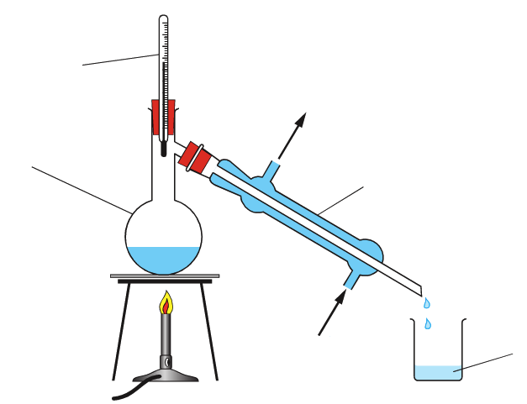

Thermometer

Condenser

Beaker

Round-bottom flask

Cool water in

Cool water out

Which of the following correctly describes the **distillate** in this procedure?

* 1. The distillate is pure water, and it is collected in the beaker
  2. The distillate is pure water, and it remains in the round-bottom flask
  3. The distillate is pure methanol, and it is collected in the beaker
  4. The distillate is pure methanol, and it remains in the round-bottom flask

1. Which of the following pairs of elements forms a compound by sharing electrons?
   1. Sulfur and lead
   2. Magnesium and oxygen
   3. Nitrogen and bromine
   4. Potassium and iodine
2. Element X has the electron configuration of 2,4 and element Y has the electron configuration 2,8,7. Which of the following best describes the compound formed between these elements?
   1. It is a covalent molecular substance with the formula XY4
   2. It is a covalent network substance with the formula XY2
   3. It is an ionic substance with the formula XY4
   4. It is an ionic substance with the formula XY2
3. Element M is a metallic element which forms positive ions. The formula of a chloride salt of Element M is MCℓ2. What is the formula of a sulfate salt of M?
   1. MSO4
   2. M2SO4
   3. M(SO4)2
   4. M2(SO4)2
4. The diagram below represents the structure of a solid chemical substance.

The solid represent is most likely to be:

* 1. Silver
  2. Iodine
  3. Graphite
  4. Sodium chloride

1. Which one of the following is the best conductor of electricity at 25 °C?
   1. H2O (ℓ)
   2. KCℓ (aq)
   3. SiO2 (s)
   4. NaCℓ (s)
2. What happens when solid calcium chloride dissolves in water?
   1. Calcium chloride molecules spread evenly throughout the water
   2. Calcium atoms and chlorine atoms react with the water to form charged ions
   3. Calcium ions and chloride ions separate from the fixed ionic lattice
   4. Calcium atoms transfer electrons to chloride atoms to form Ca2+ and Cℓ- ions
3. Which of the following best explains why diamond is a poor conductor of electricity?
   1. It is a crystalline three dimensional lattice
   2. It is made up of non-conducting carbon atoms
   3. All of the valence electrons are involved in forming covalent bonds
   4. It is a neutral substance since the number of electrons equals the number of protons
4. In 2009 a new material called graphane was discovered. The diagram shows a part of the structure of graphane. Each carbon atom is bonded to three other carbon atoms and to one hydrogen atom in a covalent network structure.

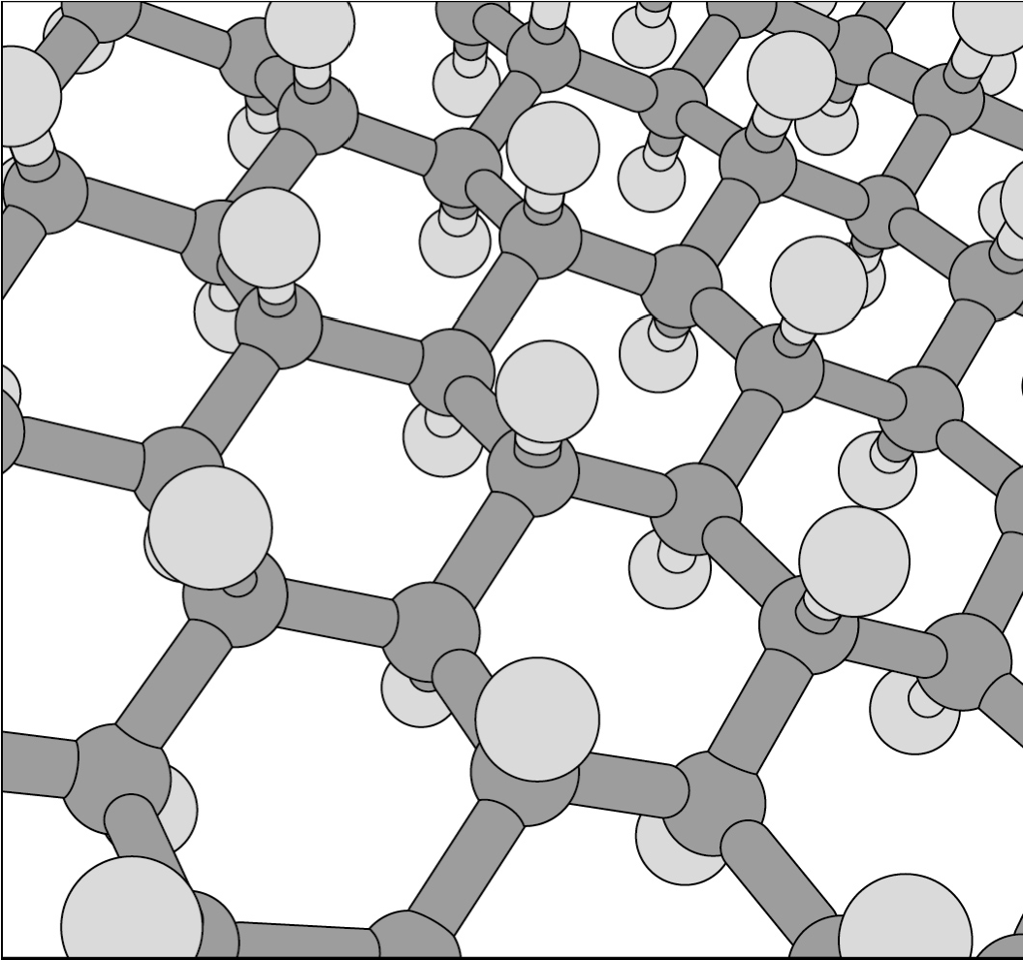

Based on the information provided, describe the likely properties of graphane.

|  |  |  |
| --- | --- | --- |
|  | **Melting point** | **Conducts electricity?** |
| (a) | High | Yes |
| (b) | High | No |
| (c) | Low | Yes |
| (d) | Low | No |

**Section Two: Short Answer**

This section has 9 questions. Answer **all** questions in the spaces provided. When calculating numerical answers, show your working or reasoning clearly. Include appropriate units where necessary. Spare working space is provided at the back. If you need to continue an answer in the spare working space, indicate this clearly next to the question.

Suggested working time: 40 minutes

1. **(5.5 marks)**

Nanomaterials are increasingly used in healthcare, electronics, cosmetics and other areas of modern society. Their physical and chemical properties often differ from those of bulk materials, so they call for specialised risk assessment.

* 1. How large is 1 nanometre (in metres)? (0.5 mark)

* 1. Define the term “nanomaterials”. (1 mark)

Carbon nanotubes are an example of a nanomaterial. Properties of carbon nanotubes include high electrical conductivity and high strength. The image below shows the structure of a carbon nanotubes.

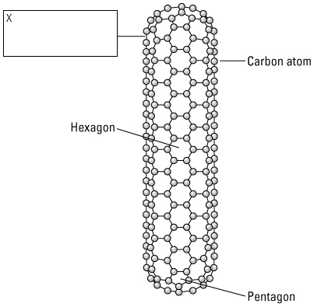

* 1. In the box labelled “X”, name the **type of bond** that forms between carbon atoms in a nanotube.

(1 mark)

* 1. Using your knowledge of structure and bonding, **explain** why carbon nanotubes:
     1. Have high strength (1 mark)

* + 1. Conduct electricity (1 mark)

* 1. A newspaper post in the UK Newspaper, The Independent, in 2013 was titled: “Top scientists call for regulation of nano-particles in consumer goods”. Professor Dame Ann Dowling of the Royal Society of Scientists noted there has been an increase in the use of nanoparticles in cosmetics and food, but little regulation about their use.

Explain, using your knowledge of nanomaterials and their properties, why these scientists feel that nanoparticles should be subject to increased regulations. (1 mark)

1. **(4 marks)**
   1. Write the formulas of the following compounds: (2 marks)

Calcium iodide

Barium carbonate

Sodium sulfide

Ammonia

* 1. Write the names of the following compounds: (2 marks)

CuO

N2O4

AgHSO4

H2O2

1. **(4 marks)**

For each of the species listed below, draw the structural formula, representing all valence shell electron pairs either as : or as –. Water has been given as an example.

|  |  |
| --- | --- |
| **Species** | **Structure (showing all valence shell electrons)** |
| Water  (H2O) | http://wps.prenhall.com/wps/media/objects/476/488316/Instructor_Resources/Chapter_10/FG10_00-19un.JPG |
| Aluminium oxide  (Aℓ2O3) |  |
| Carbon dioxide  (CO2) |  |

1. **(3 marks)**

Classify the following substances by listing them in the correct columns in the table below.

* iodine
* soft drink
* blood
* NaCℓ (aq)
* CaO(s)
* P4(s)

|  |  |  |  |
| --- | --- | --- | --- |
| **Pure substance** | | **Mixture** | |
| **Element** | **Compound** | **Homogeneous** | **Heterogeneous** |
| …………………....  …………………....  ………………….... | …………………....  …………………....  ………………….... | …………………....  …………………....  ………………….... | …………………....  …………………....  ………………….... |

1. **(4 marks)**

There are three types of strong bonding: metallic bonds, ionic bonds and covalent bonds. All of these bonds are based on electrostatic attraction between charged particles.

Complete the following table by listing the type of bond that occurs in each substance and stating the nature of attraction that occurs between particles.

|  |  |  |  |
| --- | --- | --- | --- |
| **Compound** | Silver | Diamond | Zinc oxide |
| **Type of bonding** |  |  |  |
| **Nature of attraction between particles** | Electrostatic attraction occurs between  …………………………….  ……………………………..  and  ……………………………..  …………………………….. | Electrostatic attraction occurs between  …………………………….  ……………………………..  and  ……………………………..  …………………………….. | Electrostatic attraction occurs between  …………………………….  ……………………………..  and  ……………………………..  …………………………….. |

1. **(4 marks)**

Silicon dioxide (SiO2) and sulfur dioxide (SO2) are both compounds that have covalent bonding. Despite this, SiO2 melts at 1,600 °C whereas SO2 melts at –72 °C. Explain in terms of structure and bonding why these substances have such different melting points.

1. **(4 marks)**

Pure sodium metal (Na) reacts violently with fluorine gas (F2) to form the ionic compound sodium fluoride.

* 1. Describe the arrangement of particles in a solid sodium fluoride. You may use a diagram to aid your explanation if you wish. (2 marks)

* 1. Explain why sodium fluoride does not conduct electricity in the solid state but does conduct electricity when dissolved in water. (2 marks)

1. **(6 marks)**

Power lines in Australia were historically made of copper, but are now commonly made of aluminium. Aluminium is less dense than copper, which makes it lighter and easier to suspend between power poles.

* 1. Draw a labelled diagram showing the structure and bonding within aluminium metal.

(2 marks)

* 1. Other than lightness, list **two** properties of aluminium that make it suitable for using in power cables. Explain in terms of structure and bonding why aluminium has each of these properties. (4 marks)

**Property #1:**

Explanation:

**Property #2:**

Explanation:

1. **(5.5 marks)**

It is possible to use filtration to separate pure sodium chloride (NaCℓ) from a mixture of copper chloride (CuCℓ2) and sodium chloride. To do this, ethanol is added to the mixture. The solubilities of sodium chloride and copper chloride in ethanol are 0.065 g NaCℓ per 100 g ethanol and 67 g CuCℓ2 per 100 g ethanol.

The procedure involves placing the CuCℓ2 / NaCℓ mixture into a 250 ml beaker and adding ethanol until the CuCℓ2 is just dissolved. The mixture is then filtered. The crystals in the filter paper are washed with some ethanol and then left to dry.

* 1. Label the diagram below to indicate the filtrate and the residue. (0.5 mark)

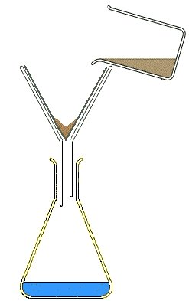

* 1. What were the crystals in the filter paper? (1 mark)

* 1. Why were the crystals in the filter paper washed with ethanol? (1 mark)

* 1. What observation would indicate that the crystals in (c) were sufficiently washed? (1 mark)

* 1. Evaporating all of the ethanol from the filtrate does not necessarily leave pure CuCℓ2. Explain why.

(2 marks)

**SPARE WORKING SPACE**

If you need to use this space to continue an answer, indicate in the original answer space that your question is continued on this page.